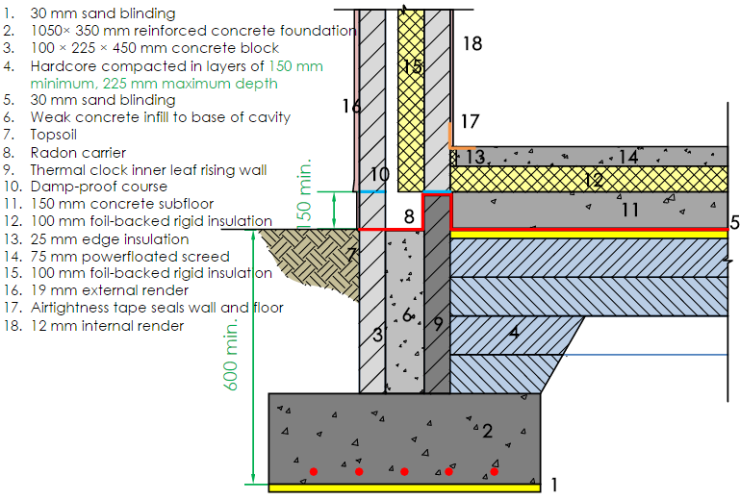
Traditional Strip Foundation – Slab + Screed

